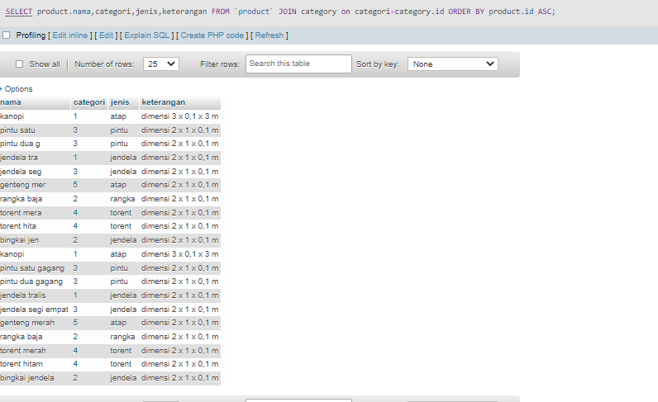

[SELECT](http://localhost/phpmyadmin/url.php?url=https://dev.mysql.com/doc/refman/8.0/en/select.html) product.nama,categori,jenis,keterangan FROM `product` JOIN category on categori=category.id ORDER BY product.id ASC

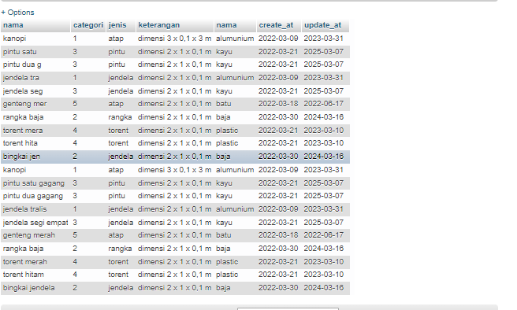

[SELECT](http://localhost/phpmyadmin/url.php?url=https://dev.mysql.com/doc/refman/8.0/en/select.html) product.nama,categori,jenis,keterangan,category.nama,create_at,update_at FROM `product` JOIN category on categori=category.id ORDER BY product.id ASC

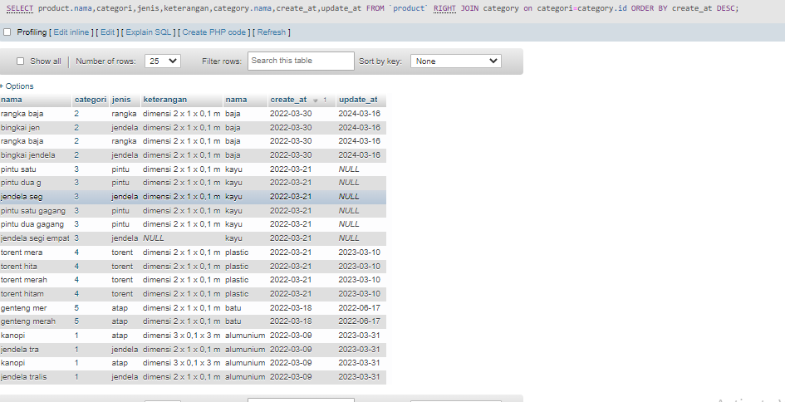

SELECT product.nama,categori,jenis,keterangan,category.nama,create_at,update_at FROM `product` RIGHT JOIN category on categori=category.id ORDER BY create_at DESC

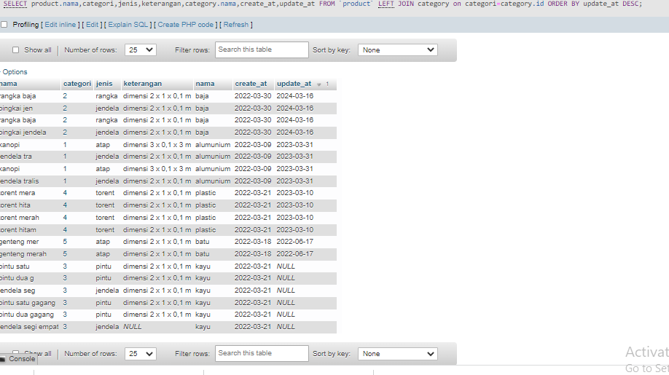

[SELECT](http://localhost/phpmyadmin/url.php?url=https://dev.mysql.com/doc/refman/8.0/en/select.html) product.nama,categori,jenis,keterangan,category.nama,create_at,update_at FROM `product` [LEFT](http://localhost/phpmyadmin/url.php?url=https://dev.mysql.com/doc/refman/8.0/en/string-functions.html#function_left) JOIN category on categori=category.id ORDER BY update_at DESC

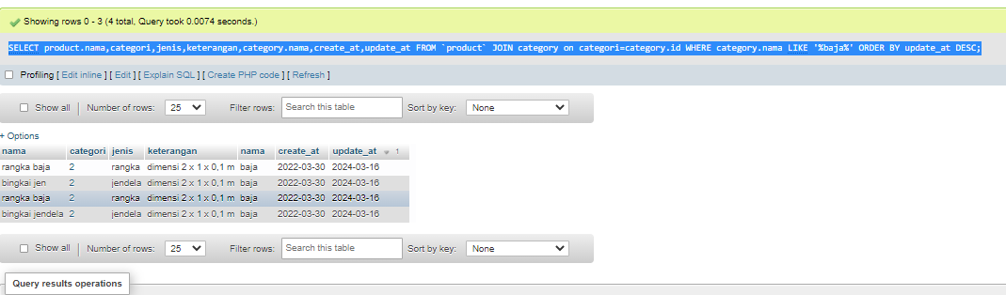

[SELECT](http://localhost/phpmyadmin/url.php?url=https://dev.mysql.com/doc/refman/8.0/en/select.html) product.nama,categori,jenis,keterangan,category.nama,create_at,update_at FROM `product` JOIN category on categori=category.id WHERE category.nama [LIKE](http://localhost/phpmyadmin/url.php?url=https://dev.mysql.com/doc/refman/8.0/en/string-comparison-functions.html#operator_like) '%baja%' ORDER BY update_at DESC

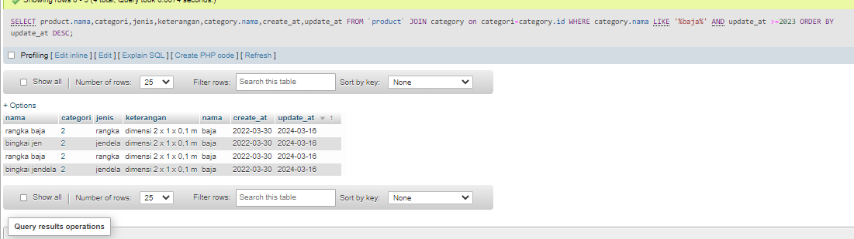

SELECT product.nama,categori,jenis,keterangan,category.nama,create_at,update_at FROM `product` JOIN category on categori=category.id WHERE category.nama LIKE '%baja%' AND update_at >=2023 ORDER BY update_at DESC